Speaking

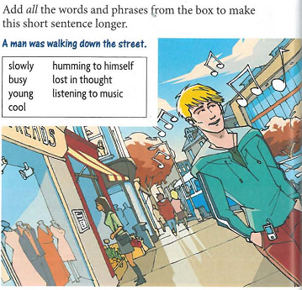

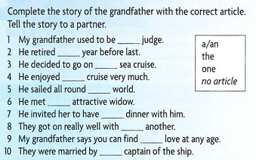

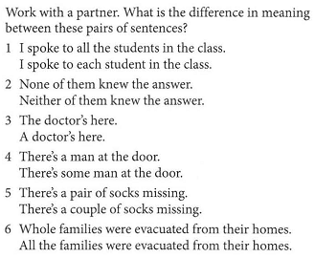

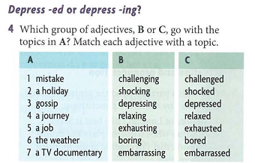

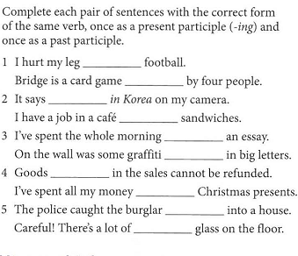

1. playing, played
2. made, making
3. writing, written
4. bought, buying
5. breaking, broken

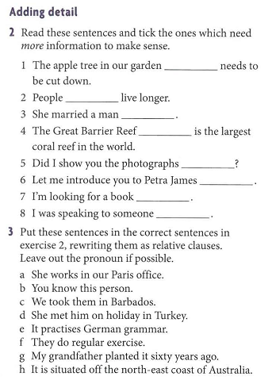

1. planted by grandfather 6 years ago G
2. doing regular exercises F
3. she’d met on holiday in Turkey D
4. situated the north-east coast of Australia H
5. taken in Barbados C
6. who works in our Paris office A
7. to practice German grammar
8. you know

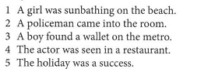

a holiday that we spent in Maldives sunbathing and swimming in the sea was a success

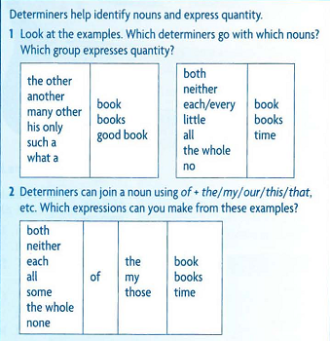

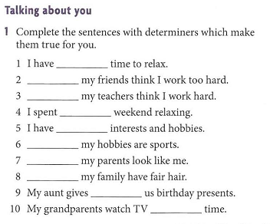

1. little
2. All of
3. None of
4. The whole
5. Some
6. All
7. Both
8. None of
9. All of us
10. All the

Home assignment

The Internet (PDF)

Ex. 1

1.D

2.G

3.B

4.C

5.F

6.A

7.E

Ex. 4

1.Avoid giving open access to PCs.

2.Never use your own programs on these machines.

3.You must not drink coffee in this lab.

4.Do not give financial information in a chat room.

5.Always keep your password in secret.

6.Use only modern anti-virus software.

7.Always use a computer with normal room temperature.

8.Never remove cards from their anti-static packing until required.

9.Use an IC extraction tool rather than using a screwdriver.

10.You must not leave your computer without switching it off.

Ex. 7

1.For a student it must be cheap value.

2.For a small business they can offer local rate calls.

3.People who enjoy playing online games should use high speed internet and a high

usage allowance

4.Someone who sends occasional emails needs junk mail filtering and virus checking.